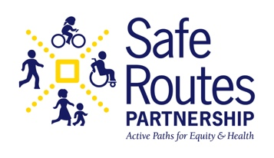
Bike and Roll to School Day
Resolution/Proclamation

Instructions for Use

- Fill in the placeholders (e.g., [CITY NAME], [SCHOOL NAME], [DATE], [MAYOR’S NAME]) with the appropriate information.
- Share the proclamation with local schools, community organizations, and city officials to encourage participation.
- Plan events and activities that promote biking and rolling to school, such as group rides, safety workshops, or school-wide challenges.
- Publicize the proclamation through social media, newsletters, and community boards to raise awareness.
- Obtain the mayor’s signature and display the signed proclamation at schools and city offices.

CITY OF [CITY NAME]
PROCLAMATION

WHEREAS, safe and active transportation, such as biking, scooting, skating, and rolling, provides children with an opportunity to develop healthy habits, build independence, and arrive at school ready to learn; and

WHEREAS, encouraging students to bike and roll to school promotes physical activity, reduces traffic congestion, improves air quality, and fosters a greater sense of community; and

WHEREAS, [SCHOOL NAME] and schools across [CITY NAME] are committed to providing safe routes for students to walk, bike, and roll to school, ensuring accessibility for all children regardless of ability or socioeconomic status; and

WHEREAS, Bike and Roll to School Day highlights the importance of safe and connected infrastructure, including sidewalks, bike lanes, and crosswalks, to support active transportation for children and families; and

WHEREAS, families, schools, and community leaders are encouraged to participate in this celebration by organizing Bike and Roll Day events, promoting safe biking and rolling practices, and advocating for safer streets for all; and

WHEREAS, the City of [CITY NAME] recognizes the efforts of local schools, educators, parents, and students in making active transportation a viable and enjoyable option for getting to and from school;
NOW, THEREFORE, I, [MAYOR’S NAME], Mayor of [CITY NAME], do hereby proclaim [DATE] as BIKE AND ROLL TO SCHOOL DAY in [CITY NAME] and encourage all schools, students, and community members to participate in activities that promote safe and active transportation to school.

IN WITNESS WHEREOF, I have hereunto set my hand and caused the official seal of the City of [CITY NAME] to be affixed this [DAY] of [MONTH, YEAR].

[Mayor's Signature]
[Mayor’s Printed Name]
Mayor, City of [CITY NAME]

