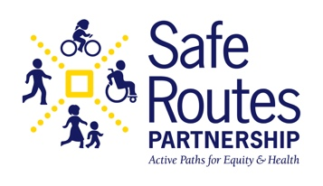
Ruby Bridges Walk to School Day Partner Email

Ruby Bridges Walk to School Day is a relatively new idea. Your partners might not know about the event or why it is important. We created this email template you can use to reach out to partners about the event. Feel free to adapt as needed!

Partner Contact List Suggestions:
- Schools
- Teachers
- Students/student groups
- Librarians
- Local historians
- Elected officials
- Artists

- Communications team
- Photographer/Videographer
- Local media
- Businesses
- Transportation advocates and Safe Routes champions
- Community organizations

Partner Email:

Dear __________,

I am organizing a Ruby Bridges Walk to School Day celebration on Thursday, November 14th at [location]. The event honors the legacy of civil rights icon Ruby Bridges who integrated her all-white school in 1960. Ruby Bridges Walk to School Day encourages young people to stand up to racism and bullying and make positive changes in their own community. It also builds upon Walk and Roll to School Day, an annual event celebrated each October in Safe Routes to School programs. Ruby Bridges Walk to School Day will provide another opportunity for students to gather with their peers and discuss issues that are important to them.

Here are a few details about our celebration:
- [Date and time]
- [Location]
- [2-3 key details about your celebration]
I would love to have our community partners join us! Here are a few ways you can get involved:
- [Volunteer at the event]
- [Spread the word on social media]
- [2-3 more ideas for how partners can participate]
Please reach out to ____________ if you are interested in participating. I look forward to hearing from you!

